**GOVERNMENT COLLEGE OF ENGINEERING [IRTT]**

**ERODE: 638 316**



**Electronics and Communication Engineering**

**NAAN MUDHALVAN**

**DIGITAL MARKETING**

**ASSIGNMENT**

NM ID: 2514FA1FA561C8A834E4C10F0985C61F

NAME: SUBHA SHREE K S

*BRAND NAME: WONKA DESSERTS*

*CATEGORY: DESSERTS*

1. Create a blog or website using Blogspot and WordPress. Customize the theme design and post new article with 500 words.

Link: Blog using Blogspot

<https://wonkadesserts.blogspot.com/2023/08/indulging-in-delight-exploring-world-of.html>

Screenshot:

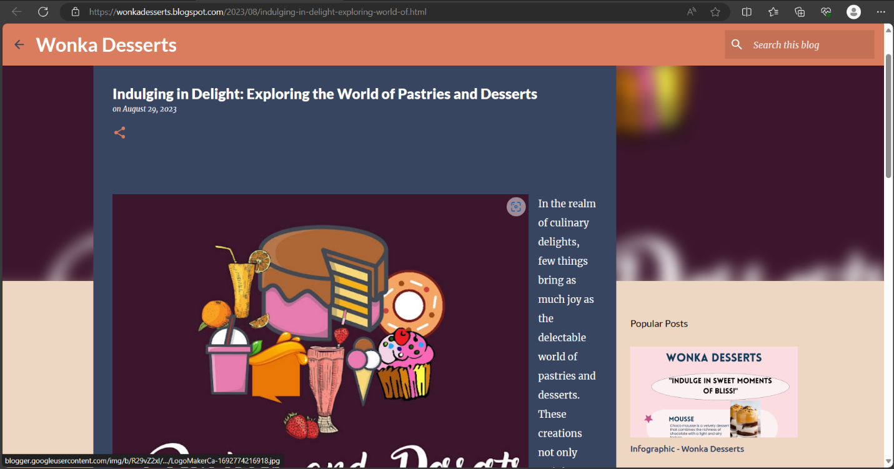

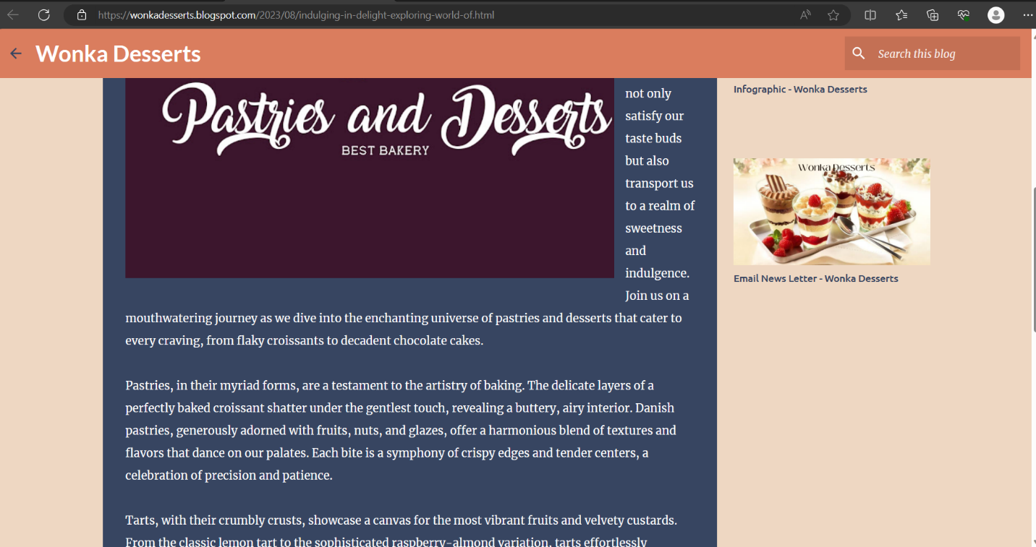

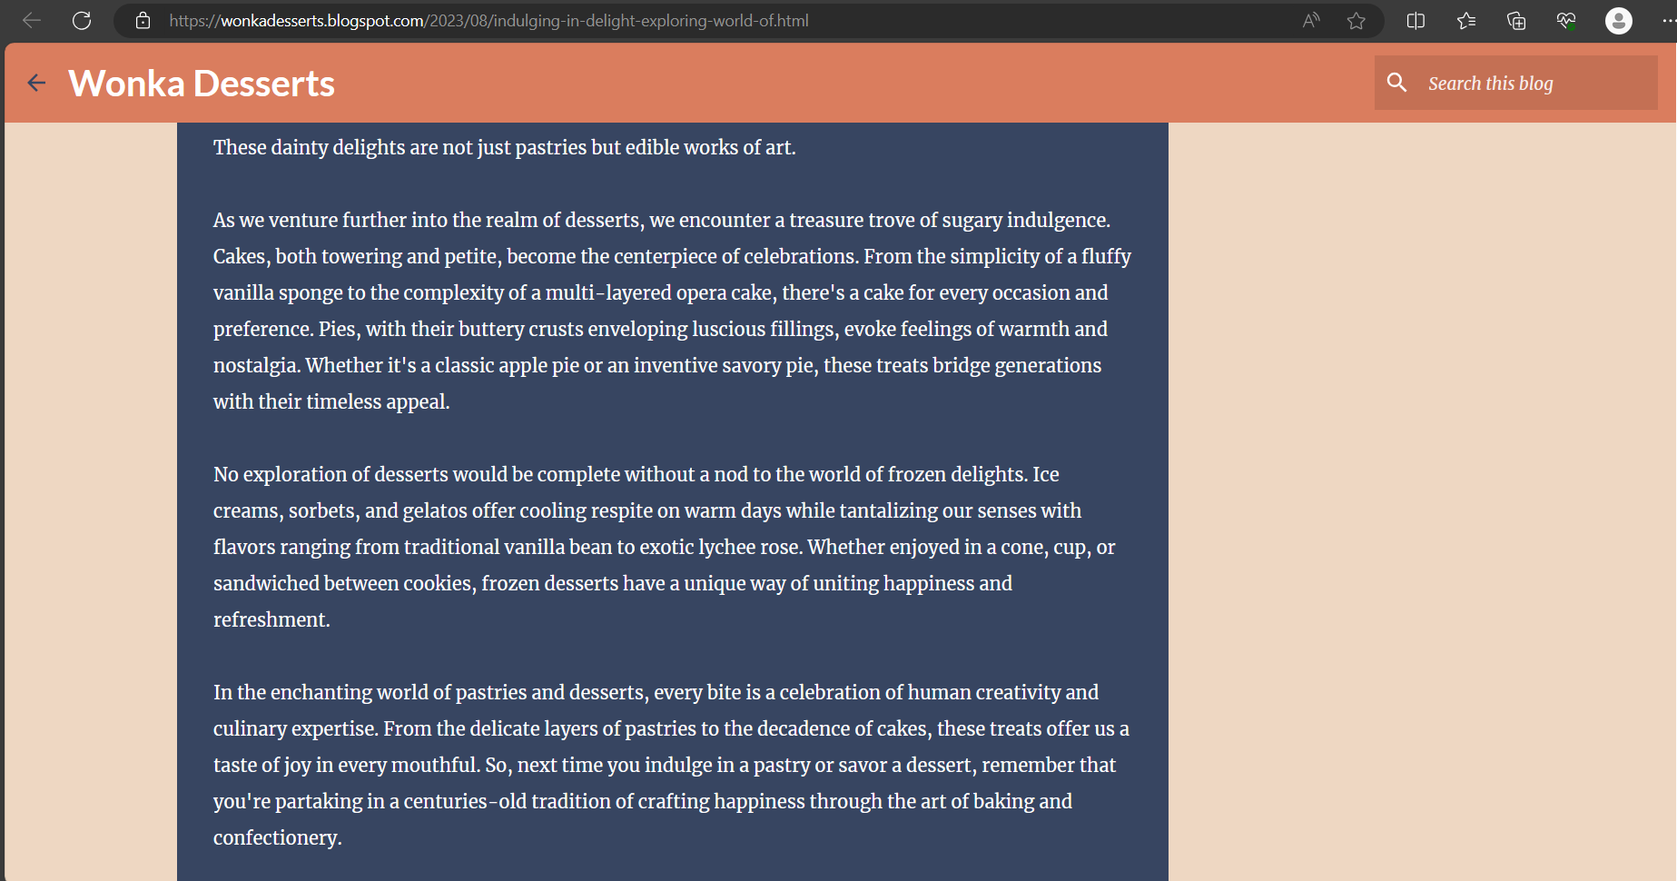

2.Create a New Facebook Business Page and post one social media poster for your brand.

Link: Facebook business page

[https://www.facebook.com/profile.php?id=61550211723698&mibextid=ZbWKwL](https://www.facebook.com/profile.php?id=61550211723698&mibextid=ZbWKwL%20)

Screen shot:

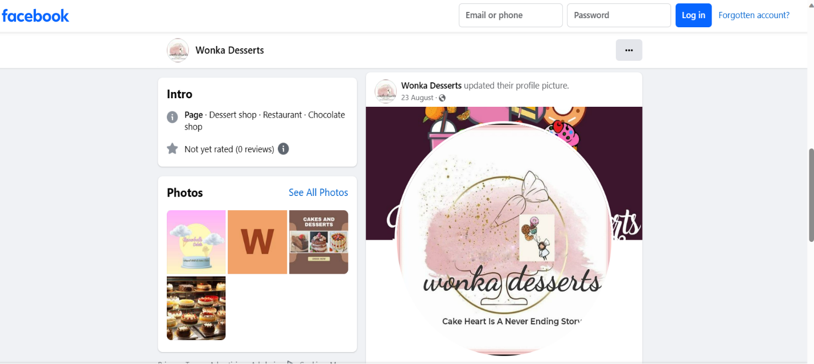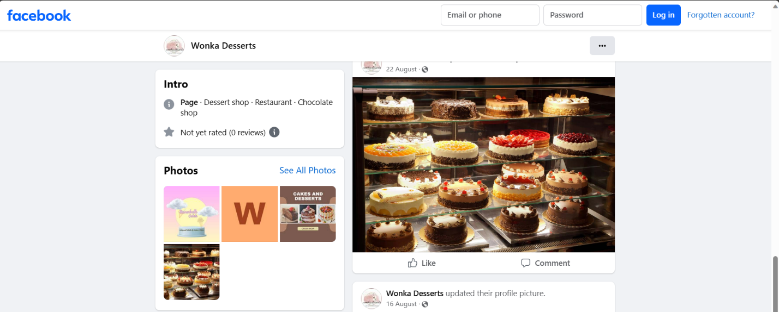

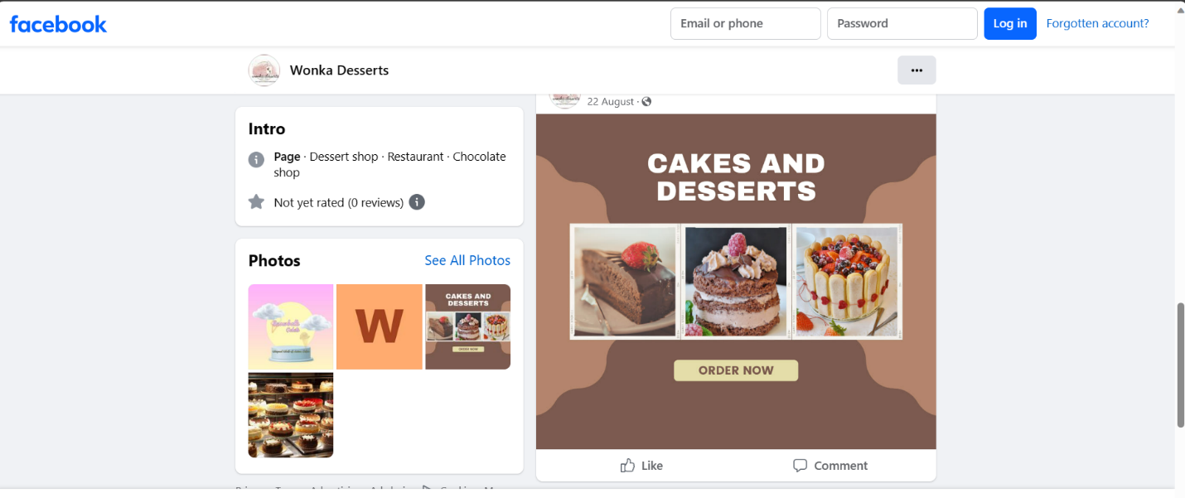

3.Create and design a social media advertisement poster using canva.

Link:

<https://wonkadesserts.blogspot.com/2023/08/infographic-wonka-desserts.html>

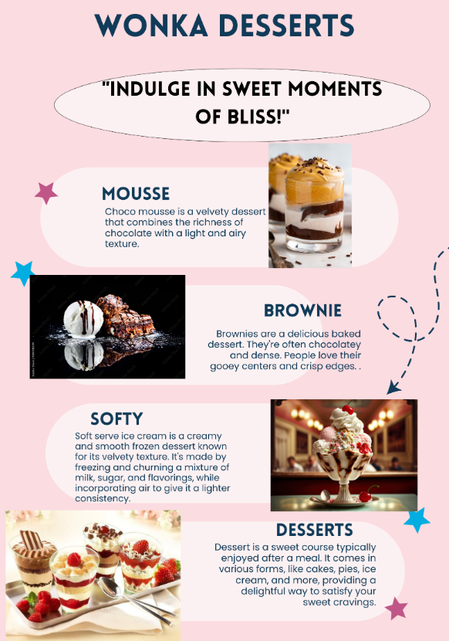

4.Create email newsletter design using MailChimp or canva tool.

Link: Email newsletter design using canva

<https://wonkadesserts.blogspot.com/2023/09/email-news-letter-wonka-desserts.html>

screen shot:

